Lab – 6
Anbar Althaf – 220962051

Outputs

q1.output

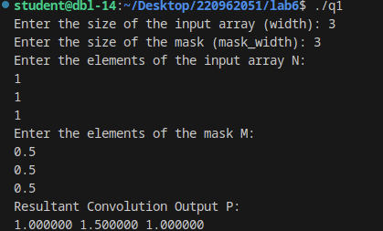

q2.output

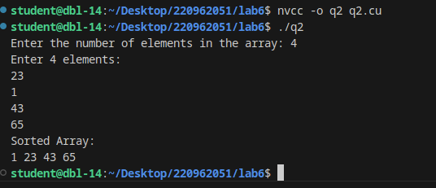
/

q3.output

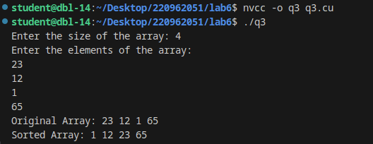
.

additional q1. Output

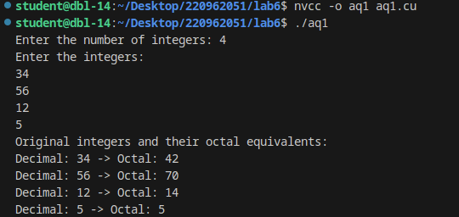

additional q2. Output

